Problem 1 [25 Points]: DFA and VW on a quick-return mechanism
A quick return mechanism is shown below. Consider the mechanism during the instant illustrated. The motor drives the crank counterclockwise at known constant angular velocity ω₃, and there is a known instantaneous reaction force F₂ (pointing to the right) acting on the end of the quick return mechanism. Assume that the full PVA analysis has already been completed. Perform a dynamic force analysis and a virtual work analysis of the mechanism to determine the required torque T₃ from the motor by following the below steps. We can assume that the slider (body 4) travels along body 2 with some friction coefficient f. An animation of a similar mechanism can be found here: https://en.wikipedia.org/wiki/Quick_return_mechanism#/media/File:Quick_Return_Mechanism_2.gif
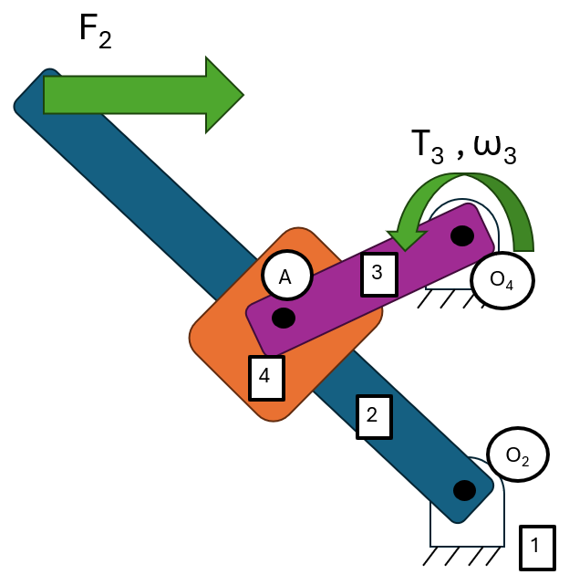

a) (3 Points) How many moving links are there in this mechanism? What is the degree of freedom of the mechanism?

b) (4 Points) List all the kinematic and dynamic parameters including those from the PVA analysis to perform DFA below, categorize the parameters into property constants (e.g. properties of links that will never change), knowns (e.g. solved variables from the PVA analysis or defined input variables that may/may not change as the crank rotates), and unknowns (e.g. output variables that need to be solved). Break vectors up into x and y components. If any variables are constrained by the design to be zero (e.g. the slider only moves in one direction) or a fixed value, identify that value.

c) (7 Points) Draw a free-body diagram of each moving link, clearly showing the coordinate system, forces, torques, relevant position vectors, and accelerations. Make the diagrams large enough to easily see each element, variable and vector (e.g. each diagram ~ ¼ page).

d) (9 Points) Apply Newton’s second law to each link and write the force and/or moment balance equations. If there are force(s) and/or acceleration(s) that have a zero x- or y-component, indicate these, and simplify associated equations to reduce the number of unknowns. List the unknown reaction forces and torques and compare them to the number of equations.

e) (2 Points) Write the equations that you found in part (d) in matrix form.

Select one of the following options:
- My answer was created by a Gen AI algorithm, and I have not modified it
- My answer was created by a Gen AI algorithm, and I have made some minor changes.
- My answer was created by a Gen AI algorithm, and I have made major changes.
- My answer was created solely by myself.
- If I used Gen AI, I used ___ (name of program).

